When the earth shook
1. Name the instrument which measures intensity, direction and duration of an earthquake.
Ans. Seismograph
2. What should we do in case of a natural disaster?
Ans. Following steps should be taken during any natural disaster:
(a) Do not spread rumours.
(b) Cooperate and encourage people to face the problems bravely.
(c) Contribute food, clothes and cash to the agencies involved in relief
work.
Give Reason.
1. How is the intensity of earthquake decided on Richter scale ?
Ans. Richter scale is used to describe the magnitude of earthquake. The range of Richter scale is from 0 to 10. An earthquake of 5.0 magnitude is 100 times more powerful than the earthquake of 3.0 magnitude. Thus ,the intensity of earthquake is decided on Richter scale.
2. Minerals containing valuable metals are extracted from deep inside the earth. How can volcanic eruption be a natural source for these minerals?
Ans. Volcanic eruptions are useful for natural resources as it brings some important and useful minerals along with lava on the surface of the earth. Certain metals are extracted from these minerals.
3. Draw neat and labelled diagram of :
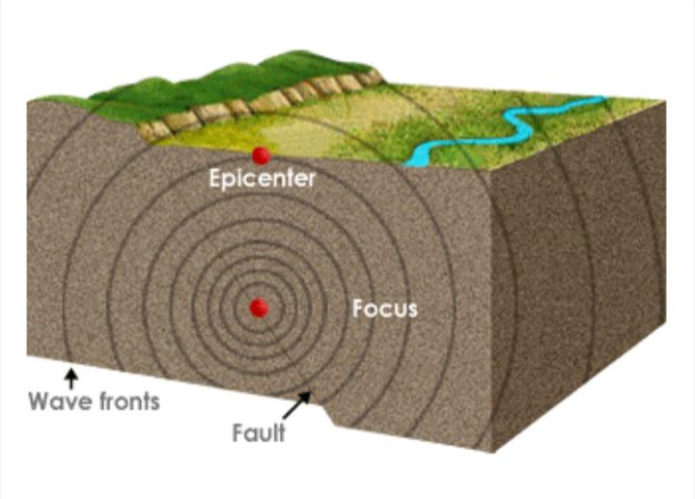
Formation of an earthquake

